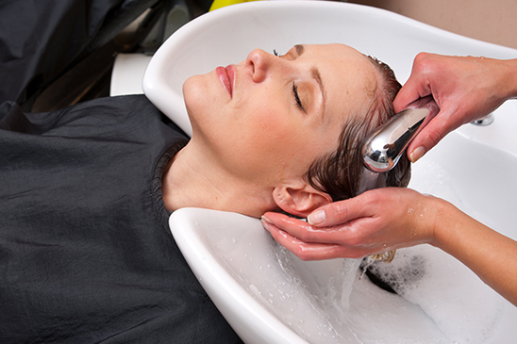
Name-Body and Mind Spa
Address- 324425, East Street, Miami
Contact-5023345345
CEO- (Put your name)

Table of Contents
Executive Summary 3
Vision/Mission 5
Company Overview 6
Product/Service Strategy 8
Market Analysis 9
Marketing Plan 10
Financial Plan 12
Supporting Documents 13
References 15

Executive Summary
My proposed name of this business is Body and Mind Spa and it will be located in Phoenix, Arizona which is a location as it falls under the lower-mile class. This business will be providing a variety of products and services with an aim of improving health, relaxation, beauty and body and mind peace. This will be achieved mainly through care treatments including facials, massages and hair. Other treatments include waxing, aromatherapy, manicures, ear candling, gua sha (scraping) and pedicures. The mission of the spa is to strive to reach beyond the hair roots and offer excellent services in a serene environment for mind and body healing.
Born 23 years ago, in a family of 3, the idea of starting my own business developed at an early age after seeing many successful businesswomen and men. This idea stroke hard in my mind and this has been my focus and put more effort into knowing which type of business I should start. The idea of starting a spa business however did not strike early as I would have expected but after identifying a market gap in Phoenix, Arizona, I know it is time to invest and venture into the spa business. There is a market gap that needed to be filled as citizens in this town lacked a diversified spa with a serene environment for customer satisfaction. The history of this business is quite young but a major inspiration in my life as I wanted to venture into something where I will dedicate my precious time and be a motivator in my life. The ideas of this business strike my mind three years ago and I am quite determined to see it a success.
The business will comprise two management personnel who are the owner who will be the CEO and the general manager. The business will be offering various products and services that include massages, waxing, tanning, skincare and facials treatment and aromatherapy, hair care products, massage products and natural hair among many others. The overall sales strategies for the business will be setting goals that are specific and differentiating the business from competitors while the overall marketing strategies will be social networks and paid media advertising. In this location, there are major competitors including Tacaloma Spa & Salon, Mynd Spa &Salon and Rochelle’s Salon & Spa. To start this business, I need $150,000. In order to obtain financing for the business, I will use a bit of my savings and borrow the rest my savings account will be the collateral as it has a good reputation.

Vision/Mission
The mission of Body and Mind Spa is striving to reach beyond the hair roots and offer excellent services in a serene environment for mind and body healing. The goals of the spa include profits increment, retention of employees, client retention, services' efficiency, top-notch services to customers, growth and high-quality products. All these goals are attainable and they become part of the objectives. The objectives of the spur include increase profits, growth, high quality products and top-notch services among others. Goal and objective settings is the backbone of every business that is successful. Focus and direction results from goals and objectives that are planned effectively and it is such a great way to grow this business and make it profitable. Therefore, I plan to attain these goals and objectives by using the golden rule of setting SMART goals. These goals and objectives are SMART which means that they are specific, measurable, achievable, relevant and time bound. These SMART goals will keep the employees motivated and turn this saloon and spa the salon that is sought-after most in the town. The vision of the future of this spa is to continue to the most sought-after spa in the country for excellent services for body and mind healing and fostering the employees’ development of professional careers. (Chappo, 2011)

Company Overview
This business is a sole proprietorship. The business is therefore run by a sole person and between this business entity and the owner, there is no legal distinction. The philosophy of the management structure of Body and Mind Spa is based on individual responsibility, every customer respect and respect all employees. The success of this spa is highly dependent on the top-notch services offered in an environment that is serene and dedicated and determined employees. The management team will therefore be made up of the owner who is the CEO and general manager. The focus of the company will be only to hire employees who are very professional and prioritize in offering top-notch services for customer retention. The responsibilities of the owner include business growth, stability and business daily operation. The responsibilities of the CEO include ensuring business legal compliance, creating and executing strategies of marketing, aligning vision and strategies of business and examining new market opportunities. The responsibilities of the general manager include day-to-day spa management, interviewing and hiring new employees, controlling inventory, and handling disputes from customers. (Chappo, 2011)
The salary structure will be the market-based structure based on what employees are paid by other employers. The CEO who is the owner will be earning $75,000 on average per year with a $45 hourly pay rate. The general manager will be earning $54,000 on average per year with a $30 hourly pay rate. Besides, both CEO and general manager will earn a 5% commission on the provided services on monthly basis. The rental charges will be $12,000 annually. Body and Mind Spa will hire several personnel including receptionist, salon assistant, cosmetologist/hairstylist, manicurist, aesthetician and massage therapist. A spa has various areas that are different including reception desk and welcome area, wet treatment rooms, dry treatment rooms, treatment showers and baths, hydro-massage, treatment lab and beauty salon. These areas have different staffing needs including job satisfaction, job stability, and employee recognition.

Product/Service Strategy
There are various products that make the spa unique and competitive. These products include hair care products, massage products, natural hair among others. On the other hand, the services that make the spa unique and competitive edge include massages, waxing, tanning, skincare and facials treatment and aromatherapy among many others. With the current technological advancement, the future development plans of products and services strategies will be based on technological innovations. Products and services in the future will be offered to the right consumer as technology will help in exploring and understanding the target audience that is right. The package design of the products will be more appealing and of high quality and the expectation of the consumers will be met by the future development plans of strategies of products and services.

Market Analysis
In this location, the populations are very diversified and comprise various race/ethnicity which includes White, Black Americans, Asian and Hispanic among others. Women are more than men and most of the adults are married with a minimum of one child. Most of the adults are businessmen and women while others are in senior executive jobs. The population of this location falls under the lower middle class as they have some education and comfortable salaries. Therefore, the majority of the population are homeowner with an annual income of between $40,500 and $122,000. The business is therefore looking to serve clients aged from 14- 60 who in this age bracket are particularly interested in salon and spa products and services. However, the business aims at attracting all clients to a serene environment to get top-notch services by professionals who care for the human body and mind.
In this area, competition is not a threat as the business is venturing as there is a niche in the market. The available salons available do not offer spa services and this will be a game-changer and revolutionize how salon and spa services and products are offered in the area. The aim of the business is to compete healthily with already established salons and spas in the area. The business despite suitable parking that is safe and secure and good accessibility, there are a few environmental risks affecting the location. One example is severe weather where it becomes extremely cold and customers barely visit the spa.

Marketing Plan
The sales strategy that will be utilized by Body and Mind Spa is that of benefits that the target market will gain. This is because many people often do not necessarily buy products and services but rather buy the results given by these products and services. Therefore, the business will start its sales process by listing the benefits that these customers will enjoy by using the products and services from the business. There are many types of advertising that can be used by the business. However, two mutual goals that are shared by all types of advertising are influencing customers and converting them into customers or even leads. Therefore, for this business, the two types of advertising that will be used are social media advertising and paid search advertising. “These will be vital as we are in a digital age and most people spend their time on the internet. Besides, social media is powerful tool in reaching and influencing consumers.” (Yousef-Sadeh & Medcalf, 2009)
In order for the business to persuade the buyer into purchasing its products and services, the promotion type it will use is advertising particularly through social media. This will play a major role in spreading awareness about the existence of the company in this location and the services and products offered. A public image that is positive to the public for any business helps to be built and maintained by public relations (PR). The public relations plan for this business will be to get organized via a set of activities that are planned and sustained. The outreach activities will be organized via a calendar. The business will fully engage and collaborate with customers, opinion leaders and personalities in this location.
Despite the business entirely focusing on social media and paid search advertising, it will also advertise on radio. An example of a radio ad is “Worried about a salon and spur serene environment for top-notch services and products for mind and body healing? Worry no more, Body and Mind Spa is ready to be your companion for excellent services that are irresistible. Visit us today and enjoy salon and spa services worth a smile. ”

Financial Plan
The business start-up cost includes initial investment, salaries, legal and accounting fees, rent deposit, decorating costs, hiring/training costs, marketing cost, office supplies, utility deposit, technical services, miscellaneous expenses, and cleaning services among others. The business is located in an environment that of the lower middle-class population with comfortable salaries. Therefore, there is a higher probability of the business accumulating profit. The proposed operating budget for one year is $450,000. The expenditures estimated for the first three years of operation are $500,000. The initial balance sheet is as follows;
ASSETS | LIABILITIES/OWNERS SECURITY
Current assets: Cash $320,000  AR $180,000  Inventory $45,000 | Current liabilities: AP $70,000  Notes payable $20,000
Total current assets $545,000 | Total current liabilities: $90,000
Fixed Assets: Fixtures $50,000 | Long-term liabilities/Debts: Other loans $190,000
Total fixed assets: $50,000 | Total long-term debts: $190,000
Total assets: $595,000 | Total liabilities: $280,000
 | Net worth:$315,000
I will use the funds I am requiring to revamp the business and create a serene environment for customer satisfaction. In order to get the loan, the collateral I will use is savings accounts where I have a good reputation. I intend to pay the loan through the profit realized by the business after becoming the business becomes stable.

Supporting Documents
The floor plan
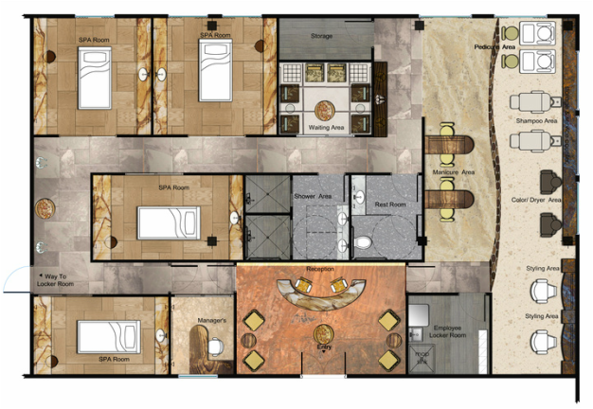
Job descriptions

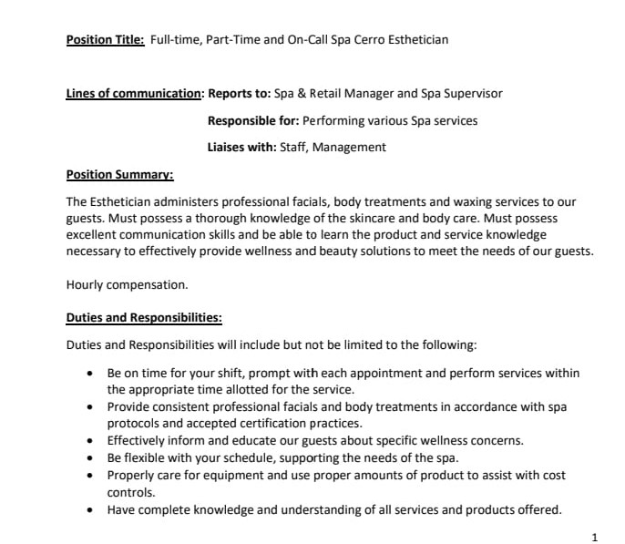

References

Chappo, L. L. (2011). How to start up and manage your own hair salon: --and make it BIG in the salon business : tips, tricks and secrets to get more clients into your chair!. El Cerrito, Calif.: Heart to Heart Living.

Iwegbu-Daley, E. (2008). Open your own salon-- the right way!: The complete step by step guide to planning, launching and managing your own salon business!. London: Agushka.

Yousef-Sadeh, B., & Medcalf, S. (2009). Start and run a successful beauty salon: A comprehensive guide to managing or acquiring your own salon. Oxford: How To Books.

